Happy Green Children
platform user guide:

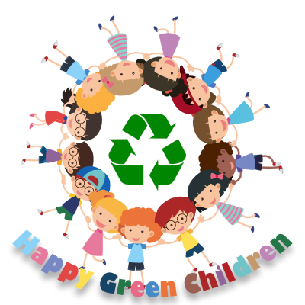

Although the Happy Green Children website is easy to use and available in English, Spanish and Portuguese, we’re going to provide a step-by-step guide on how to access the platform, create a new user profile and log in with a password, and how to use the platform with a guest login.

Accessing the platform

access the platform through the official website https://happygreenchildren.eu/

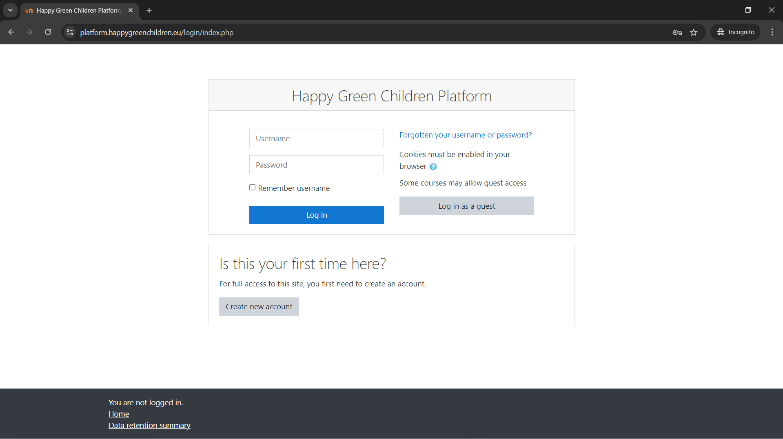

The picture above showcases the first page that pops-up when you access the platform

Create a new account
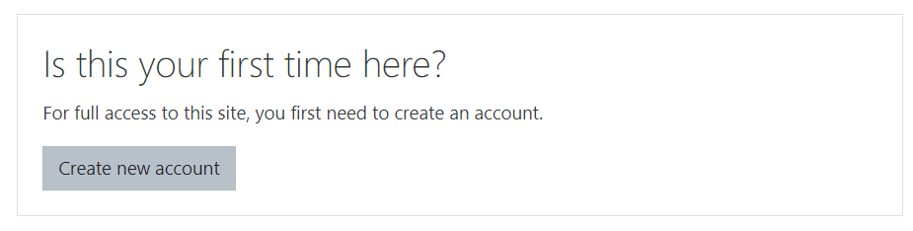

Once you click on ‘’ create new account’’ it will redirect you to the next page

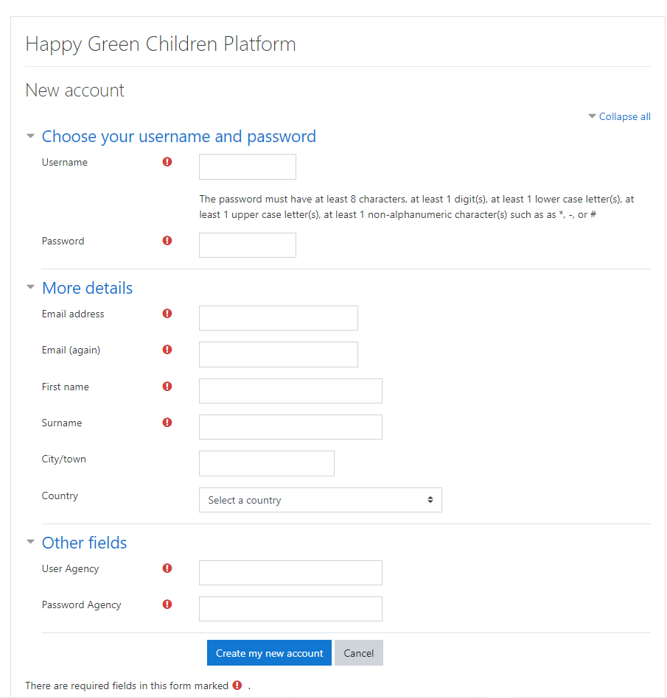
Fill in all your details and click ‘’ create my new account’’. All fields marked  are mandatory to fill.

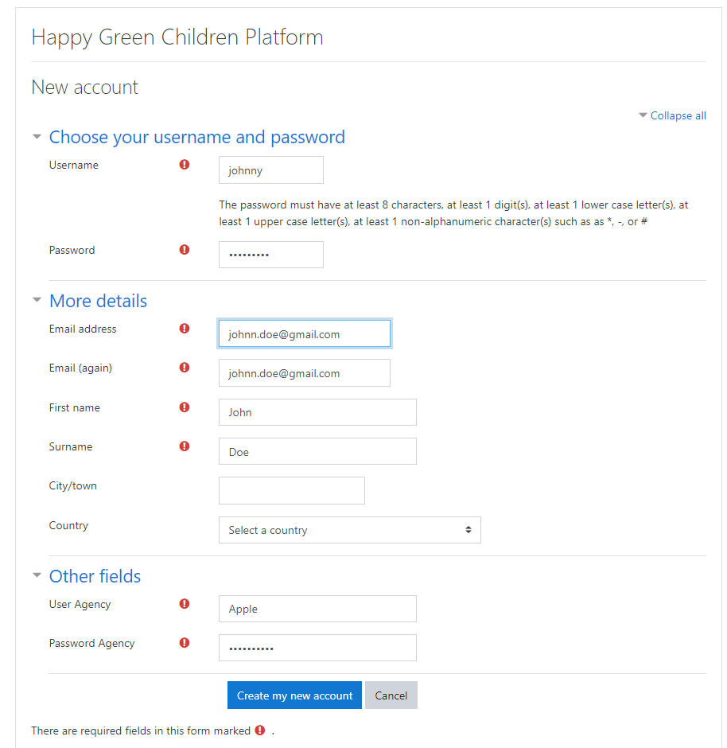

Registry Confirmation through e-mail

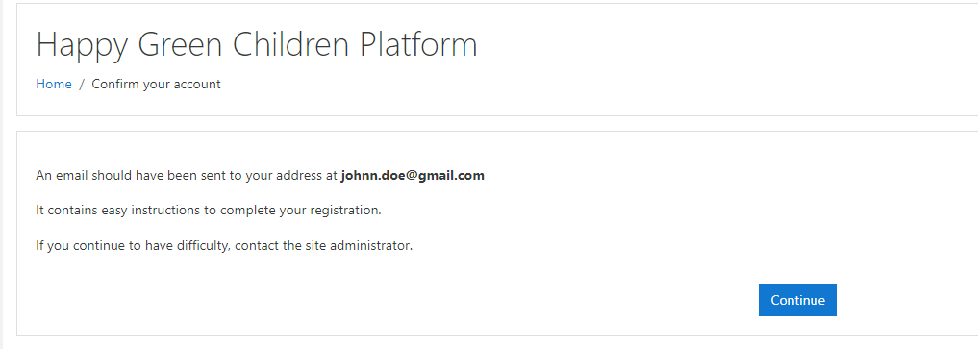

An email will be sent to the address provided.
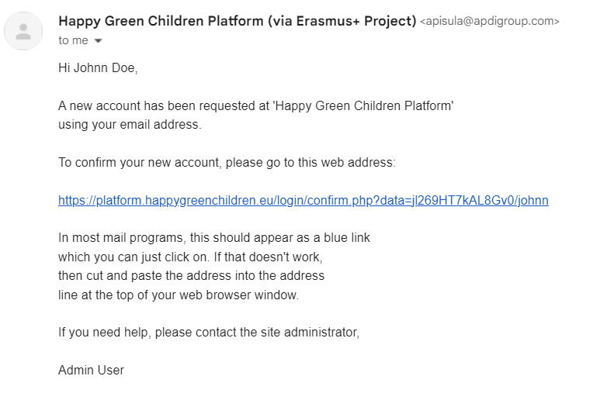
When you receive the e-mail click on the link to confirm.

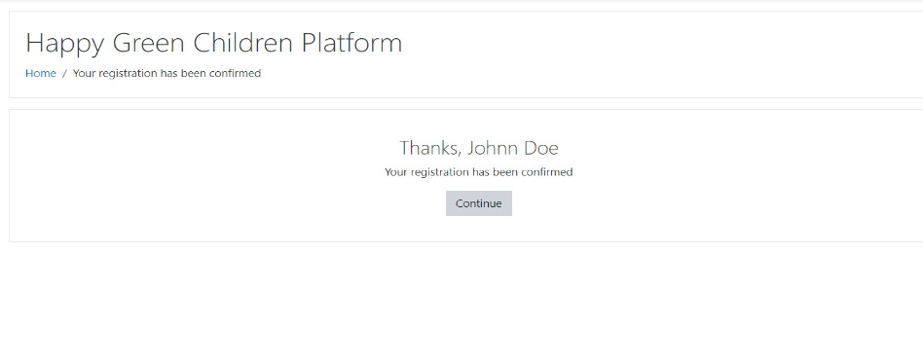
You will be redirected to this page indicating the confirmation of your registry.
Login as a user

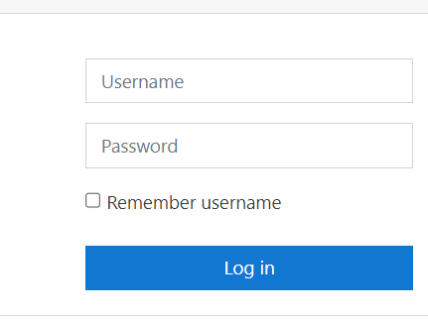
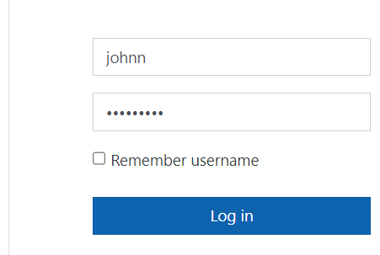

Go to the platform login page and inter user’s name and password and log in

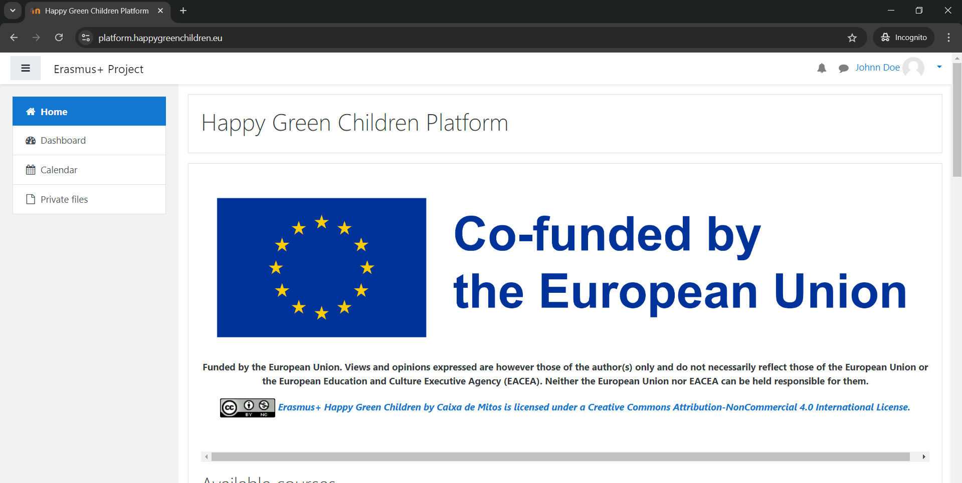

You will be logged in into the platform on the left corner you can see the User ID

Guest login

You can always access the platform without having to log in as a user all you have to do is to click on guest login and enable cookies in your browser

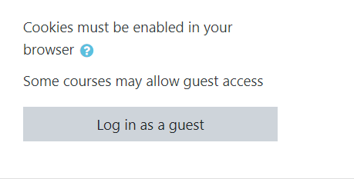
Once you’re logged in as a guest the platform will be on display

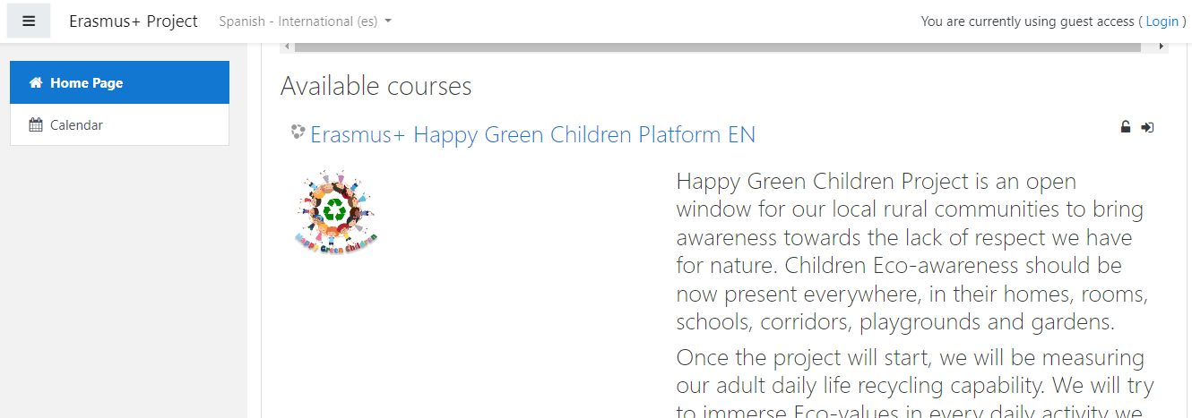

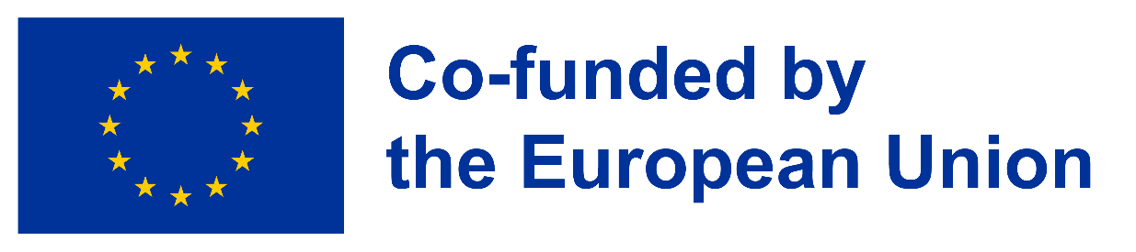
Funded by the European Union. Views and opinions expressed are however those of the author(s) only and do not necessarily reflect those of the European Union or the European Education and Culture Executive Agency (EACEA). Neither the European Union nor EACEA can be held responsible for them.
Erasmus+ Happy Green Children by Caixa de Mitos is licensed under a Creative Commons Attribution-NonCommercial 4.0 International License.

